Women’s Studies Centre (funded by UGC),
Report on ASER Survey 2024
Date: 27th November 2024 to 30th November 2024
Organized by: Department of Women’s Studies, Bharathidasan University, Khajamalai Campus, Tiruchirappalli & Women’s Studies Centre (funded by UGC), Holy Cross College (Autonomous), Tiruchirappalli
Event: Annual Status of Higher Education (ASER) Survey 2024
From 27th to 30th November 2024, the Department of Women’s Studies, Bharathidasan University, Khajamalai Campus, Tiruchirappalli, and the Women’s Studies Centre (funded by UGC), Holy Cross College (Autonomous), Tiruchirappalli, jointly participated in the Annual Status of Higher Education (ASER) Survey 2024. The ASER Survey focuses on assessing the status of higher education in rural areas, with a particular emphasis on access, enrollment, and the socio-economic barriers that impact educational opportunities.
On 27th and 28th November 2024, the ASER staff conducted an orientation session in Department of Women’s Studies, Bharathidasan University, Khajamalai Campus, Tiruchirappalli, for the participating students, where they were introduced to the survey methodology, data collection techniques, and the importance of gathering accurate information. The session also covered how to engage with the local communities, conduct interviews, and ensure data reliability. This orientation was crucial in preparing the students for the fieldwork that followed.
Following the training, on 29th and 30th November 2024, the students participated in the fieldwork across five rural locations: Lalgudi, Manachanallur, Mahilambadi, Nerujalakudi, and Anadhanallur. They interacted with students, parents, and teachers to assess various aspects of higher education, including enrollment rates, available resources, challenges faced by students—particularly women—and the level of awareness about educational schemes and opportunities in these areas.
In recognition of their participation, all students involved in the survey received a certificate of participation. In addition, they were also compensated for their efforts with a stipend for their time and work during the field survey.
This hands-on experience allowed the students to apply their academic knowledge to real-world research and provided them with valuable insights into the educational challenges faced by rural communities, particularly regarding women's access to higher education. The data collected will play an important role in contributing to the national ASER Survey 2024, offering valuable information that can inform future educational policies and initiatives aimed at improving access to higher education in rural India.
The collaborative effort not only contributed to the ASER Survey but also empowered the students by offering practical skills in field research, data collection, and community engagement, further enhancing their understanding of gender issues in education.

Annual Status of Education Report (ASER)
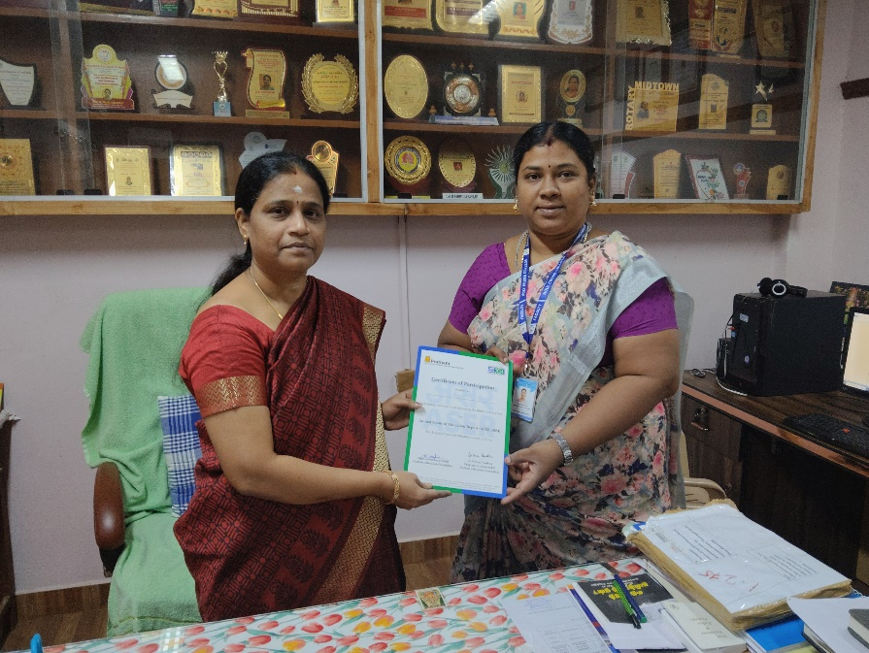
The Women's Studies Centre (Funded by UGC), Holy Cross College (Autonomous), Tiruchirappalli, has actively participated in the Annual Status of Education Report (ASER) 2024, the largest citizen-led education survey in India. We appreciate and acknowledge their valuable contribution toward assessing and improving the status of education in the country.
As a result of their significant contribution, the Women's Studies Centre (Funded by UGC) and its Coordinator received an award certificate for partnership.
The certificate was presented by Prof. N. Murugeswari, Director & Head of the Department of Women’s Studies, Bharathidasan University, Khajamalai Campus, Tiruchirappalli.
The certificate was received by Dr. Prisheela P, Assistant Professor and Coordinator of the Women's Studies Centre (Funded by UGC), Holy Cross College (Autonomous), Tiruchirappalli, on 11th March 2025, at 11:00 AM at the Department of Women’s Studies, Bharathidasan University, Khajamalai Campus, Tiruchirappalli.

